A safari across France: soil fauna insights from a nationwide soil quality monitoring program

Authors: Sophie Pouzenc1, Claudy Jolivet1, Louna Abraham2,3, Apolline Auclerc4, Eric Beaucher5, Antonio Bispo1, Nolwenn Bougon6,Matthias Brand2,3, Laurence Carteaux5, Camille Chauvin7, Daniel Cluzeau8, Jérôme Cortet2, Jean-François David9, Loris Delourme5,8, Thomas Gelis2,3, Sarah Guillocheau10, Camille Imbert1,11, Antoine Lévêque12, Gwenaël Magne2,3, Nicolas Henon2,3, Franck Noël13, Guénola Pérès5, Mathias Peron14, Samuel Prunot2,3, Philippe Reisdorf15, Olivier Rose16, Marc Roucaute5, Cyril Versavel3, Cécile Villenave7, Quentin Vincent14, Mickaël Hedde3

Affiliations

1 INRAE, Info&Sols, Orléans, France

2 University of Montpellier Paul Valéry, University of Montpellier, EPHE, CNRS, IRD, Montpellier, France

3 Eco&Sols, INRAE, IRD, CIRAD, Institut Agro, Univ Montpellier, Montpellier, France

4 Université de Lorraine, INRAE, LSE, Nancy, France

5 Institut Agro, INRAE, UMR SAS, Rennes, France

6 OFB, Vincennes, France

7 Elisol Environnement, Congénies, France

8 University of Rennes, CNRS, ECOBIO, Rennes, France

9 CEFE, Univ Montpellier, CNRS, EPHE, IRD, Montpellier, France

10 Independent ecologist, Mauron, France

11 Leibniz-Centre for Agricultural Landscape Research (ZALF), Müncheberg, Germany

12 PatriNat, OFB, MNHN, CNRS, IRD, Paris, France

13 Independent researcher, Vimartin-sur-Orthe, France

14 EODD Ingénieurs Conseils, Nancy, France

15 Independent researcher, Boullay-lès-Troux, France

16 Réseau Entomologique ONF, Villemaréchal, France

**Abstract**

Soil biodiversity is fundamental to ecosystem functioning but remains underrepresented in conservation policies and large-scale monitoring. Here, we present RMQS-Biodiversity, a nationwide soil biodiversity survey integrated into the French Soil Quality Monitoring Network (RMQS), and illustrate its potential for soil ecology research. In this pioneer study, we examine three major ecological aspects: (i) how systematic grid-based sampling captures micro-food web patterns using nematode communities, (ii) the spatial turnover of detritivore communities (Collembola, Isopoda, Diplopoda) in response to environmental and geographic gradients, and (iii) the influence of macroecological drivers on predator (Carabidae) morphological traits. Across 69 sites, we identified a few widespread species coexisting with numerous rare taxa, underscoring the value of large-scale surveys for detecting cryptic biodiversity. Nematode indicators revealed high variability in food web structure across land uses, with increased facultative phytophagous nematodes in forests. Isopods and diplopods were strongly structured by dispersal constraints, while springtails exhibited weaker environmental responses, likely due to their higher dispersal capacity. Additionally, sexual size dimorphism in Carabidae varied by habitat, with female-biased dimorphism in closed habitats but no dimorphism in open environments, highlighting habitat stability’s role in shaping morphological traits. This study demonstrates the value of multi-taxon, multi-trophic biodiversity assessments in long-term soil monitoring. RMQS-Biodiversity provides a robust framework for soil biodiversity monitoring and conservation, refining bioindicators of soil quality and informing policies such as the EU Soil Monitoring Law.

**Keywords**

Soil biodiversity monitoring – Macroecology – Soil invertebrates – Bioindicators – RMQS

**Highlights**

RMQS-Biodiversity is a nationwide soil biodiversity monitoring framework.

A standardized multi-taxon approach enables large-scale soil biodiversity survey.

This national dataset will establish a baseline for long-term biodiversity monitoring.

RMQS-Biodiversity will support bioindication and policy-relevant biodiversity assessments.

1 Introduction

Soil fauna plays a fundamental role in maintaining ecosystem functioning, yet it remains a less explored component of biodiversity [(FAO et al., 2020)](https://www.zotero.org/google-docs/?gW3dwk). Comprising a vast array of organisms—from microscopic nematodes to larger invertebrates such as springtails, macro-arthropods and earthworms—soil fauna contributes to key ecological processes. This includes organic matter decomposition, nutrient cycling, soil structure formation, and plant growth promotion [(Angst et al., 2024; Bonfanti et al., 2025; Briones, 2014)](https://www.zotero.org/google-docs/?oWfZHE).

Despite its critical role in ecosystem functioning, soil fauna remains relatively poorly understood, particularly in terms of its spatial and temporal dynamics [(Gérard et al., 2025; Köninger et al., 2022; Zeiss et al., 2022)](https://www.zotero.org/google-docs/?uWqfM6). Both alpha diversity (local species richness) and beta diversity (community turnover across space and time) are influenced by a complex interplay of environmental, climatic, and anthropogenic factors [(Calderón-Sanou et al., 2024; Thuiller et al., 2024)](https://www.zotero.org/google-docs/?u2hLgG), yet large-scale patterns and their underlying drivers remain largely unresolved [(Anthony et al., 2023)](https://www.zotero.org/google-docs/?dwSbhY). Many soil invertebrate species in France, particularly diplopods and isopods, show restricted geographic ranges, likely due to their low dispersal ability, strong dependence on specific habitat conditions, and historical biogeographic constraints [(Kime and Enghoff, 2021, 2017, 2011; Séchet and Noël, 2015)](https://www.zotero.org/google-docs/?7tD5ZH). Such restricted ranges contribute to increased β-diversity between regions, because communities differ strongly when locally endemic or specialized species are present. However, the relative contribution of environmental dissimilarity versus geographical distance in shaping this spatial turnover of communities remains poorly understood.

These restricted ranges and their consequences for β-diversity illustrate the broader knowledge gaps that still limit our ability to predict soil fauna diversity responses to global change and land management, and to design effective conservation strategies [(Gérard et al., 2025; Zeiss et al., 2022)](https://www.zotero.org/google-docs/?ulO7nP). To bridge these gaps, a transition is needed from documenting local or taxon-specific patterns to developing integrated frameworks that combine macroecological perspectives with long-term monitoring and conservation-oriented approaches [(Santini et al., 2021)](https://www.zotero.org/google-docs/?48Xyk8). Macroecology by focusing on large-scale patterns and temporal scales, emphasizes statistical relationships and general principles governing biodiversity, species distributions, ecosystem functions, and environmental gradients [(Diniz-Filho, 2023)](https://www.zotero.org/google-docs/?wo4xj2). Macroecology often tests so-called macroecological laws, such as species–area relationships, latitudinal gradients in diversity, or sexual size dimorphism (SSD) as formulated in Rensch’s rule (Fairbairn et al., 2007). eesve

Although such patterns are well documented for many aboveground taxa, they remain poorly explored for soil invertebrates. By leveraging standardized methodologies and broad-scale biodiversity assessments, it will be possible to enhance our understanding of trends in soil fauna diversity, their ecological drivers, and their implications for ecosystem resilience and sustainability. Indeed, soil fauna faces multiple threats, including habitat destruction, intensive land use, pollution, climate change, and biological invasions [(Arias-Navarro et al., 2024; Gardi et al., 2013; Orgiazzi et al., 2016)](https://www.zotero.org/google-docs/?ilCGTn), all of which can disrupt key ecological processes and reduce ecosystem resilience [(Wall et al., 2015)](https://www.zotero.org/google-docs/?frA6N6). Despite these risks, soil organisms remain largely overlooked in conservation policies and monitoring frameworks [(Gérard et al., 2025)](https://www.zotero.org/google-docs/?dQQBWL). The project of EU Soil Monitoring Law highlights the urgent need for reliable indicators to assess soil quality and biodiversity [(European Commission, 2023)](https://www.zotero.org/google-docs/?WEhPh5), reinforcing the necessity of improving our understanding of soil organism ecology.

Several monitoring programs across Europe or worldwide aim to assess soil biodiversity and its role in ecosystem functioning [(Bispo et al., 2021)](https://www.zotero.org/google-docs/?cZqc8F). For instance, programs such as the LUCAS Soil Survey at the EU level, and national biodiversity observatories integrate soil biological indicators into their frameworks. These initiatives vary in scope, methodology, and objectives, ranging from broad-scale soil quality assessments to more targeted studies on specific taxonomic groups. Furthermore, most of these programs are temporary and therefore are not usable to assess long term soil biodiversity trends [(Imbert et al., 2023b)](https://www.zotero.org/google-docs/?xEyXk5). Despite important efforts to develop and support these programs, major challenges remain in harmonizing methodologies, ensuring long-term data continuity, and linking soil biodiversity indicators to ecosystem functioning and policy frameworks. Strengthening these monitoring efforts is essential to provide a comprehensive understanding of soil biodiversity trends and their implications for sustainable land management and conservation.

The French Soil Quality Monitoring Network (RMQS) has been implemented in France since 2000 [(Arrouays et al., 2003)](https://www.zotero.org/google-docs/?MVVoD3). This network of 2240 sites is based on a systematic grid covering continental France and overseas territories (French Guiana, West Indies, Reunion and Mayotte islands), with a fifteen-year sampling frequency. For twenty-five years, this network has provided data at a national level on soil parameters distribution and evolution [(Froger et al., 2021; Meersmans et al., 2012; Rabot et al., 2024; Saby et al., 2009)](https://www.zotero.org/google-docs/?k2zwk9), also contributing to fill knowledge gaps on soil microorganisms (bacteria, archaea and fungi) [(Karimi et al., 2018)](https://www.zotero.org/google-docs/?jyd0aG). Following a recommendation to initiate a comprehensive monitoring of terrestrial biodiversity in France [(Touroult et al., 2017)](https://www.zotero.org/google-docs/?uTRj9T), then as part of listed actions in the 2018 French national Biodiversity Plan, and, more recently, the development in France of a National Terrestrial Biodiversity Monitoring Program, the French Office for Biodiversity (OFB) asked INRAE to consider a soil biodiversity monitoring including micro-organisms (bacteria, fungi, protists) as well as micro-, meso-and macro-fauna. This network is called RMQS-Biodiversity and was deployed in 2024 over the French territory during the second sampling campaign of the RMQS.

This study asks whether a nationwide, systematic grid design can simultaneously improve our understanding of fundamental ecological processes in soil fauna and provide robust baselines for soil bioindication. We hypothesize that RMQS-Biodiversity, by covering diverse land uses, taxa and trophic groups in a standardized manner, will reveal new ecological patterns while refining indicator ranges.

To explore this, we focused on three aspects of soil fauna ecology. First, focusing on the micro-trophic food web, we examined whether the grid approach helps refine nematode indicators by capturing a wider range of values, including unusual or rarely sampled habitats. Second, we looked at how detritivore communities (springtails, woodlice and diplopods) change with environment and distance, in order to tease apart the roles of niche effects and dispersal limits. Third, we tested whether a classic macroecological pattern – Rensch’s rule of SSD – can be detected in top predators (ground beetles) across contrasting vegetation structures. Closed vegetation (forests and shrublands) provide more stable and resource-rich conditions, while open (croplands and grasslands) are more disturbed and resource-limited, conditions that may constrain how much individuals invest in body mass and thus shape SSD.

From these questions we formulated three hypotheses: (i) the nationwide grid will capture the wide intra-land use variability of nematode communities, including rare or atypical situations, while also clearly discriminating differences between land uses, (ii) β-diversity of detritivores is more strongly shaped by dispersal limits in isopods and diplopods than in springtails, and (iii) sexual size dimorphism in Carabidae differs between closed and open habitats, providing a first test of Rensch’s rule for soil invertebrates.

2 Materials and Methods

2.1 RMQS scheme

The French Soil Quality Monitoring Network has been implemented in France since 2000. This programme is supported by the Scientific Interest Group Soil ([www.gissol.fr](http://www.gissol.fr)) and is coordinated by the INRAE Info&Sols research unit. This network of 2240 sites is based on a 16 km x 16 km systematic grid covering continental France and overseas territories. The RMQS has been designed to be representative of the main soils and land uses across France including agricultural fields, meadows, urban gardens, wastelands, forests, vineyards, orchards, and other natural environments [(Jolivet et al., 2022)](https://www.zotero.org/google-docs/?HpvGSU). Historical and actual management practices are collected on each RMQS site in order to facilitate data interpretation and modelling. The RMQS generates thousands of samples a year that are prepared for analysis and stored in the European soil samples archive. Samples may be used for a posteriori analysis of changes over time, to check any analytical drift or for re-examination using new techniques. RMQS data are gathered in a national soil information system including operational databases, a data warehouse and a set of user interfaces built to capture and share the data. The 1st campaign took place from 2000 to 2015 and the 2nd campaign started in 2016 and is expected to end by 2031. It will provide data to document the evolution of soil quality with major issues related to soil organic carbon dynamics and climate change, soil contamination and human health, soil water content regulation and soil biodiversity. As part of the development of a comprehensive monitoring of terrestrial biodiversity in France, a network called RMQS-Biodiversity was deployed in 2024 over the French territory during the second sampling campaign of the RMQS. A test on 30 study sites was performed from 2020 to 2022 [(Imbert et al., 2023a)](https://www.zotero.org/google-docs/?rwh360).

Figure 1 illustrates the locations of the 2024 sampling campaign (Figure 1A & B) and the RMQS-Biodiversity sampling layout (Figure 1C). The sampling strategy of the RMQS is based on a regular grid of 16 × 16 km, and approximately 180 sites are sampled each year during the second campaign at the centre of each 16 × 16 km cell. At each site, a 20 × 20 m sampling design is set up to collect composite samples at several soil depths (in most cases: 0 – 30 cm, 30- 50 cm, 50 – 75 cm, 75 – 100 cm). In addition, a soil pit is dug nearby in order to describe the soil profile and collect samples from each horizon. The set of protocols implemented are described in the RMQS2 manual (Jolivet et al. 2022). The central blue square represents the standard RMQS sampling area (20 × 20 m). Due to the disruptive nature of the hand-sorting protocol, this area was extended to a 32 × 32 m square for the biodiversity assessment to avoid high disturbance in the standard RMQS sampling area.

2.2 Protocols for soil biodiversity assessment

2.2.1 Sampling period

In spring 2024, we characterized the biodiversity of a subset of 69 sites sampled in 2023 for the RMQS (Figure 1A & B), in order to take advantage of the logistics already in place the previous year (contact with landowners/managers, exact positioning of the sampling area, complete physico-chemical analyses). Unlike RMQS soil sampling, which is carried out throughout the year by various service providers (agricultural chambers, scientists, private companies, etc.), we deployed three dedicated teams to conduct biodiversity sampling during the most favorable period, from late winter (mid-March) to early spring (mid-June) according to local climate. A few high-altitude sites in the Alps and Pyrenees were sampled in July to account for the specific constraints of these environments. The spatial distribution of replicates is shown in Figure 1C.

2.2.2 Soil sampling

Twenty-five auger samples (4 cm diameter) from 0–30 cm depth were collected within the elementary sampling areas (blue cells in Figure 1C) and pooled to create a composite soil sample for each site. Within each elementary plot, the sampling point was randomly selected within a one-meter radius around the marker, with no preference given to terrain features (e.g., depressions, elevations, or proximity to the marker). Samples were consistently taken from [(Jolivet et al., 2022)](https://www.zotero.org/google-docs/?umClZD). The composite soil sample was subsequently used for physico-chemical analyses, environmental DNA metabarcoding, and nematode community assessment. Only the nematode analysis is presented in this paper.

2.2.3 Nematode extraction and identification

Nematodes were extracted from 300 g of the previous composite soil sample (fresh weight) by Ostenbrink elutriation followed by cotton–wool filter step [(ISO 23611-4, 2007)](https://www.zotero.org/google-docs/?jBhRCB) and counted under a binocular microscope. After fixation in formaldehyde–glycerol (4%), 220 specimens per sample were identified to family and genus levels in mass slides under a microscope.

2.2.4 Microarthopod extraction and identification

From each sampling site (Figure 1), 3 cores of surface soil (0–5 cm depth, 6 cm diameter, yellow circles in Figure 1C) were collected after the removal of litter (when present), according to [ISO 23611 (2024)](https://www.zotero.org/google-docs/?Jgj35g). Microarthropods were extracted from soil cores through dry extraction for 7 days, according to [Macfadyen (1961)](https://www.zotero.org/google-docs/?qrp7WL). The temperature above the cores was increased during extraction from 35 °C (2 days) to 45 °C (2 days) and then to 60 °C (3 days), while the temperature below the cores was kept at 5 °C. Collected animals were preserved in 70% ethanol. For each soil sample, Collembola were counted and identified at morpho-species level under a stereo-microscope (Kyowa optical, SDZ-TR-PL, 7 to 45× magnification). Specimens were clarified in Marc André solution I and mounted in Marc André solution II [(André, 1946)](https://www.zotero.org/google-docs/?IdAfCL). Species identification was checked using phase-contrast microscopy (Zeiss, Axio Scope A1, 200 to 630× magnification) according to various dichotomous keys [(Bretfeld, 1999; Hopkin, 2007; Dunger and Schlitt, 2011; Jordana, 2012; Potapow, 2001; Thibaud et al., 2004)](https://www.zotero.org/google-docs/?0XNuta).

2.2.5 Macrofauna sampling and identification

Soil dwelling macroinvertebrates were collected using a combination of hand sorting and chemical expulsion with mustard. A solution was prepared shortly before sampling by diluting 15 g mustard (‘*Amora fine et forte*’) in 500 mL of tap water, adapted from [ISO 23611-1 (2018)](https://www.zotero.org/google-docs/?wYYuED). At each station, six soil monoliths (25 × 25 cm, 20 cm deep) were excavated using a spade, following the edges of a metal frame (green squares in Figure 1C). Blocks were extracted quickly to reduce animal escape, then placed in individual trays. Immediately after extraction, the mustard solution was slowly poured into each pit over 20 minutes. Pouring was paused if ponding occurred. All animals surfacing during this period were collected continuously. Simultaneously, each soil block was hand-sorted by crumbling to fragments <1 cm. Earthworms and macrofauna were extracted progressively, rinsed if needed, and preserved in 96° ethanol.

Ground-dwelling macroinvertebrates were sampled using pitfall traps, with six traps placed in each RMQS station (purple circles in Figure 1C). They were partly filled with salt-saturated vinegar, used as a preservative medium [(Hedde et al., 2013)](https://www.zotero.org/google-docs/?efvm3Y). Traps were left for four weeks and the collected invertebrates were then preserved in 96° ethanol for identification later.

In the laboratory, individuals collected by hand sorting and with pitfall traps were identified at the highest possible resolution under stereomicroscope with dedicated identification keys. Concerning the most diverse/abundant groups, we used [Bouché (1972a)](https://www.zotero.org/google-docs/?eyGoiT) for earthworms, [Vandel (1962, 1960)](https://www.zotero.org/google-docs/?K0VMDn) for isopods, [Demange (1981)](https://www.zotero.org/google-docs/?u9PVYE) for diplopods, [Gloor et al. (2010)](https://www.zotero.org/google-docs/?OkvC33) for spiders, [Blatrix et al. (2013)](https://www.zotero.org/google-docs/?UvynGM) for ants, [Coulon et al. (2011)](https://www.zotero.org/google-docs/?DsVcAK) for ground beetles. These identification keys, some of which are dated, were used as foundational references and supplemented with more recent resources. The current French taxonomic referential, TaxRef v18, was used as a standard for taxonomy [(Gargominy, 2025)](https://www.zotero.org/google-docs/?5r5b4o).

2.3 Nematode indicators

The taxa were grouped according trophic groups (Yeates et al., 1993) and a colonizer-persister (cp) class [(Bongers, 1994)](https://www.zotero.org/google-docs/?po6mHz). The c-p scale classifies nematodes into five groups, including opportunistic feeders with short generation times and high reproduction rates (cp1), generalist feeders with the ability to develop when resources are limited (cp2), and persisters with long life spans, low reproduction rates, and greater sensitivity to soil disturbances (cp3–cp5). The combination of the c-p scale and feeding habits defines functional guilds as proposed by Bongers and Bongers (1998) and allows to assign to each taxa a functional guild and to calculate nematofauna indices [(Ferris et al., 2001)](https://www.zotero.org/google-docs/?eUGNEn).

We computed the abundance of three main functional guilds, i.e. free-living nematodes (which include bacterial feeders, fungal feeders, omnivores and carnivores), facultative plant feeders and obligate plant-feeders. We also computed two major nematode ecological indices involved in soil food web diagnostic, the Enrichment index (EI) and the Structure index (SI) (Ferris et al. 2001). A high value of EI indicates a high nutrient availability in the soils whereas a high value of SI indicates a complex trophic web and a stable environment. The Enrichment index (EI) and the Structure index (SI) are indices developed specifically for analyse of nematode assemblage. The entire procedure is presented in the reference (Ferris et al. 2001). Significant differences in nematode abundances (total and by functional guilds) among land uses were tested using the non-parametric Kruskal–Wallis test. The “urban park” (1 station) and “permanent crops” (orchards, vineyards; 3 stations) categories are displayed for visual comparison with the three main land uses (croplands, meadows/pastures, and forests), but they were not included in the statistical analyses due to their very limited sample size, which would have resulted in a highly unbalanced design.

2.4 Spatial turnover of detritivore community composition

We analyzed the beta diversity of soil detritivores (Collembola, Isopoda, and Diplopoda) using Generalized Dissimilarity Modeling (GDM). This approach allows for assessing how environmental gradients influence community composition turnover across space. Only individuals identified at the species level were retained for further analysis, i.e. 351 out of 516 Diplopoda (68%), 1207 out of 1246 Isopoda (97%) and 2307 out of 3066 Collembola (75%). The three final datasets included the species presence/absence data of 51 Collembola species, 21 Isopoda species, and 27 Diplopoda species, respectively. For diplopods and isopods, we joined the data obtained by pitfall traps and hand sorting, which gave complementary species lists at site scale. Beta diversity was computed for all possible community pairs using Sørensen's dissimilarity index. GDM were built separately for each taxon group [(Ferrier et al., 2007)](https://www.zotero.org/google-docs/?05FLhj). Community composition turnover was modeled as a function of environmental gradients and geographical distance.

For the environmental predictors, we selected variables describing climatic, soil, and vegetation conditions, each representing different aspects of species’ ecological niches. We followed the framework proposed by Calderon-Sanou et al. (2022, 2024) and Martinez-Almoyna et al. (2024). We grouped predictors into five sets: above-ground habitat, climate, soil “stress” variables (acting as physiological constraints), soil texture, and soil nutrients and carbon. The above-ground habitat characteristics included the vegetation characteristics (Normalized Difference Vegetation Index —NDVI) and the type of ecosystem (closed habitats such as forests and shrublands vs. open habitats like croplands, pastures, and meadows).

Soil properties were extracted from the RMQS dataset [(INRAE, 2022)](https://www.zotero.org/google-docs/?gxXcNG). It included granulometry (clay and sand proportions), nutrient content (C/N ratio, total organic carbon and CaCO3 content, cation exchange capacity), pH, and metal concentrations (exchangeable cadmium and lead contents). Spatial predictors (longitude and latitude) were included to account for the geographic structuring of biodiversity patterns.

The final models were fitted using the gdm package in R [(Ferrier et al., 2007)](https://www.zotero.org/google-docs/?gDf4l5), following these key steps: (i) formatting the data with the formatsitepair() function to create site-pair matrices; (ii) fitting GDM models separately for each detritivore group; and (iii) extracting predictor importance from the model coefficients. The obtained relationship between predicted ecological distance and community dissimilarity illustrates how well the model predicts differences in community composition based on environmental and spatial distances. A strong relationship indicates that sites with greater ecological distance (i.e., differing more in environment or location) also tend to have more dissimilar communities.

2.5 Carabidae body-mass scaling

We weighed all well-preserved individuals identified to the species level. The dataset comprises 9,167 individuals, of which 8,889 were retained after removing broken or incomplete specimens. The average individual mass of males and females for each species in each station was calculated, resulting in a dataset with 611 rows (representing station-species combinations) and 2 columns (male and female). We used analysis of covariance (ANCOVA) to test whether the parameters of the linear relationship between the average male and female mass (log-transformed) in a local population were influenced by habitat type (open vs. closed). Statistical tests were conducted using the car package (Levene’s test) and the stats package (Shapiro-Wilk test, ANCOVA) in RStudio [(Bolar, 2019; Fox et al., 2001)](https://www.zotero.org/google-docs/?KaTnTG).

3 Results

3.1 Collected taxa

About 35 millions nematodes, 10,578 microarthropods and 48,773 macroinvertebrates were extracted or collected. A total of 15 500 nematodes individuals (223 in average per site) were identified to family level, belonging to 49 families. The spider community comprised 226 species across 25 families, with Linyphiidae (85 species), Lycosidae (37 species), and Gnaphosidae (32 species) being the most represented families. A total of 229 Coleoptera species were recorded, spanning at least 27 families, with Carabidae dominating (128 species). Collembola diversity included 51 species from 15 families, mainly Isotomidae (12 species) and Hypogastruridae (10 species). From the pitfall, we identified at least 35 earthworm species from two families, predominantly Lumbricidae (34 species). As the identification from hand-sorting and mustard is only completed at 90%, these results are not integrated in the analysis. Diplopoda were represented by 27 species across nine families, primarily Julidae (9 species), while Isopoda included 21 species from eight families, with Armadillidiidae (6 species) being the most abundant. Among Hymenoptera, only ants (Formicidae) were identified to the species levels, with a total number of 50 species recorded. The species list is available in [Annex A](https://docs.google.com/spreadsheets/d/1T_8r4g1-YYt9iMah-dyAy9X5B78C3Mayz2b9KoF8LZE/edit?gid=0" \l "gid=0).

Considering all the taxa identified at species level, only 47 species have been collected in more than 20% of the stations, and can be arbitrarily considered as common, representing less than 8% of the total collected species pool (541) (Figure 2). *Parisotoma notabilis* (Schäffer, 1896), *Allolobophora chlorotica* (Savigny, 1826), *Poecilus cupreus* (Linnaeus, 1758), *Tenuiphantes tenuis* (Blackwall, 1852), *Lasius niger* (Linnaeus, 1758) and *Philoscia muscorum* (Scopoli, 1763) displayed the highest occurrence rate of their respective taxa (Collembola-61%, Oligochaeta-58%, Carabidae-51%, Araneae-48%, Formicidae-43% and Isopoda-32%, respectively). Reciprocally, most of the species (92%) were present in less than 20% of the stations, including all the diplopoda species. This pattern may intensify or be reduced when incorporating other groups with high (acari, insects) or low (centipedes) diversity, which have not been identified at species level yet.

3.2 Nematode-based indicators of soil quality

Figure 3A illustrates the distribution of the 69 sampled sites based on the Enrichment Index (EI) as a function of the Structure Index (SI), with data points spanning all four quadrants. The majority of sites are clustered in the upper portion of the graph, where EI values exceed 50. Specifically, over 80% of annual crop plots have an EI above 50, compared to 50% of grassland sites and 60% of forest sites. The lowest SI values are observed in agricultural plots under annual cropping, with five sites registering an SI below 8. In contrast, forests contain a high proportion of plots with elevated SI values: 45% of forest sites exhibit an SI above 75. Among the forests with SI values below 45, four out of five represent atypical cases: two dry garrigue sites, a recently clear-cut area, and a former pasture undergoing reforestation.

For comparisons of nematode abundances amongst land uses, the urban site and the three "permanent crop" sites were excluded due to their limited representation within their respective categories, but displayed in Figure 3B for visual comparison. No significant differences were detected in the total abundance of free-living nematodes among the three major land-use types (annual crops, grasslands, and forests) (Kruskal-Wallis χ2 = 1.861, p-value = 0.394). No differences were detected in the abundance of opportunistic bacterivores (Kruskal-Wallis χ2 = 4.615, p-value = 0.100), fungivores (Kruskal-Wallis χ2 = 0.087, p-value = 0.957) and omnivores+predators (Kruskal-Wallis χ2 = 4.396, p-value = 0.111). Bacterivores from cp2-4 differed between land uses (Kruskal-Wallis χ2 = 7.443, p-value = 0.024), being more numerous in pasture and meadow than in annuals crops (data not shown). In contrast, obligate plant-feeding nematodes (i.e., phytoparasitic nematodes) were found to be statistically five times less abundant in forest soils compared to annual crops and grasslands. No significant difference was observed between annual crops and grasslands. Conversely, facultative plant-feeding nematodes were significantly more abundant in forest soils than in annual crop plots, with their relative proportion in the total nematode community reaching exceptionally high levels. Remarkably, in 35% of forest sites, facultative plant-feeding nematodes comprised more than 70% of the total nematode assemblage.

3.3 Spatial turnover of detritivore community composition

Overall, the GDM models explained varying proportions of the compositional dissimilarity among the three detritivore groups (Figure 4A). Woodlice exhibited the highest explained variance (14.5%), followed by diplopods (12.2%) and springtails (2.3%). For woodlice, community composition was primarily influenced by environmental stress factors (e.g., pH, heavy metals; 6.0%), along with carbon resources and nutrient availability (4.0%). Climate, habitat, and geographic variables had moderate effects (1.3-1.7%), whereas soil texture showed no detectable influence. Diplopod community structure was predominantly shaped by habitat characteristics (8.7%, structure and density of the vegetation), with low contributions from other environmental factors (0-1.2%). In contrast, springtail communities appeared weakly structured by the measured environmental variables (0.1-0.6%), as indicated by the low explanatory power of the model.

The relationship between predicted ecological distance and community dissimilarity varied among taxonomic groups (Figure 4B). In springtails, the relationship was weak, with a high intercept (0.68) and a visually unstructured scatterplot, indicating no clear saturation across the range of modeled ecological distances. For diplopods and isopods, the scatterplots were more structured, reflecting a stronger response to ecological distance. The models revealed lower intercepts (0.24 for diplopods and 0.13 for isopods), along with rapid saturation of compositional dissimilarity, suggesting that most community turnover occurred at relatively short ecological distances.

The response curves of some key influential environmental variables exhibited non-linear patterns, with marked differences in the relative importance of predictors among taxonomic groups (Figure 4C). Isopods showed clear trends in response to geographic distance, soil total organic C and average daily temperature. Diplopods showed an exponential response to NDVI for the highest values of the monitored gradient, while response rapidly saturated to geographic distance and soil total organic C.

3.4 Carabidae body-mass scaling

The mass of c.a. 9,000 individuals, grouped by species, are represented in Figure 5A. The smallest recorded species are *Tachyura parvula* (Dejean, 1831) and *Tachys bistriatus* (Duftschmid, 1812), with average masses of 0.14 mg (n = 1 individual) and 0.19 mg (n = 3 individuals), respectively. In contrast, the largest species are *Carabus coriaceus* Linnaeus, 1758, and *Carabus monilis* Fabricius, 1792, with average masses of 1365.3 mg (n = 1 individual) and 830.9 mg (n = 31 individuals), respectively.

ANCOVA results indicate that the average masses of males and females are strongly correlated within the same population (same station) (p = 2e-16) and that habitat type has a significant effect on the slope (p = 0.043). Figure 5B shows that the relationship between average male and female mass in each station differs between open and closed habitats. In closed habitats, females are larger than males, with this difference being more pronounced in species with a lower average mass (Figures 5B and 5C). In contrast, individuals collected in open habitats do not exhibit sexual dimorphism, as the slope and intercept did not differ from 1. This result indicates that the size ratio between the sexes is 1 and remains constant across the range of body mass.

4 Discussion

Assessing common and rare species for soil quality assessment

We found 50 ants, 35 earthworms, 226 spiders, 129 ground beetles, 51 springtails, 27 diplopods and 21 woodlice species, representing 24%, 17%, 14%, 13%, 9%, 8% and 5%, respectively, of the known species pool of mainland France (INPN, [Gargominy, 2025)](https://www.zotero.org/google-docs/?V3OgZs). These percentages are calculated with respect to the entire national pool, regardless of habitat. A smaller fraction of these species is strictly edaphic, especially in groups with both soil-dwelling and epigeic representatives (e.g. spiders, ants, carabids), whereas earthworms, springtails, diplopods, and woodlice are predominantly soil- or litter-dwelling taxa (Anthony et al., 2023). In particular, many species inhabit specific environments that cannot be sampled by the RMQS, such as superficial subterranean habitats, caves, riverbanks, or aquatic environments.

As expected, a few common species (8% of the species list) dominated the assemblages within each taxonomic group, reflecting their broad ecological tolerance and wide distribution across the sampled sites [(e.g. Callaghan et al., 2021 for birds)](https://www.zotero.org/google-docs/?lkQTOf). Hence, species occurrences are left skewed: our survey revealed several rare species, highlighting the effectiveness of our sampling design in capturing a representative snapshot of soil biodiversity. Notably, among the spiders, we recorded species with highly restricted distributions. According to the INPN ([Gargominy, 2025)](https://www.zotero.org/google-docs/?V3OgZs),, *Harpactea lepida* (C.L. Koch, 1838) and *Pardosa pyrenaica* Kronestedt, 2007 were previously known from one and two locations respectively, while *Harpactea arguta* (Simon, 1907) was known from four locations, three of which were identified before 1914. Similarly, some diplopods (*Occitaniulus rouchi* [Mauriès, 1965](https://www.zotero.org/google-docs/?sUSIYd)) and earthworms (*Gatesona serninensis* [(Bouché, 1972b)](https://www.zotero.org/google-docs/?iZvJf9)) species, typically considered rare or poorly documented in mainland France, were identified in our dataset.

Large-scale monitoring is crucial for revealing taxa that would otherwise stay under the radar. Our current inventory is based on the very first year of sampling, so the share of the national species pool will inevitably rise in the coming years. We will also keep track of how quickly new species appear in the dataset, as this is a useful measure of completeness. The grid design is valuable not because it is exhaustive, but because it captures several groups of soil fauna across contrasting land uses within a single, standardized framework. Finally, adding an explicit focus on rare species may strengthen bioindication, since these taxa can be both sensitive markers of habitat quality and active contributors to ecosystem stability.

Nematodes

The analysis of nematode communities across these 69 sites did not reveal any significant differences in the total abundance of free-living nematodes between different land uses. We intentionally chose not to detail the various groups of free-living nematodes (e.g., opportunistic bacterivores, other bacterivores, fungivores, and omnivorous predators) to focus on one specific group that stands out in studies based on systematically selected sites: the facultative plant-feeders. In our work, these nematodes are particularly over-represented in forest soils. However, previous studies indicate that nematode communities in forests are usually dominated fungivorous taxa [(Kondratow et al., 2019; Okada and Kadota, 2003)](https://www.zotero.org/google-docs/?ogbngp). In some stations, facultative plant-feeders accounted for over 70% of the nematode community. Their role in soil ecological functioning warrants further investigation, as facultative plant-feeders may influence root performance and, indirectly, biotic interactions in the rhizosphere.

Sampling based on a systematic grid approach also provides access to conventionally farmed plots, where biological indicators are rarely implemented. In the soil trophic network diagnostic diagram (plotting EI vs. SI, Figure 3), these plots are typically positioned in the upper left corner, indicating a low Structure Index (SI) and a high Enrichment Index (EI) [(Puissant et al., 2021; Villenave et al., 2013)](https://www.zotero.org/google-docs/?pnKFnc). Among the 23 annual crop plots examined in the 2024 RMQS-Biodiversity study, four exhibited such characteristics. Notably, biological diagnostics using soil nematofauna in France are often conducted in agricultural fields managed by farmers who are already engaged in agroecological approaches and are seeking solutions to improve their practices. ELISOL-Environnement reports that conservation agriculture (e.g., no-till) and organic farming are over-represented among the agricultural plots assessed for biological functioning, a trend that became evident during the validation of the Sipanema decision-support tool [(Villenave et al., 2022)](https://www.zotero.org/google-docs/?sZVXZQ).

In contrast, forest sites are predominantly positioned on the right side of the soil trophic network diagnostic graph (EI vs. SI), reflecting their more stable environments compared to annual crop plots. However, grassland plots display a much wider distribution on this graph, highlighting their inherent heterogeneity at large scale. Indeed, grasslands exhibit high biological diversity, as reflected in their nematode communities. This diagnostic graph serves as a valuable tool for distinguishing plots with distinct biological functioning [(Du Preez et al., 2022)](https://www.zotero.org/google-docs/?3gMwja).

Unravelling spatial turnover of detritivore communities

Our results demonstrate that the beta diversity patterns of detritivorous arthropods—springtails, isopods, and diplopods—are driven by different sets of environmental and spatial factors. Despite their shared ecological function in organic matter transformation, these taxa exhibited contrasting responses to geographic distance and environmental gradients, suggesting distinct dispersal capacities, ecological tolerances, and responses to habitat heterogeneity.

The variation in the explanatory power of the GDM models among taxonomic groups suggests that dispersal ability plays a key role in shaping beta diversity patterns. Diplopods and isopods showed strong spatial structuring of community composition, with rapid saturation of dissimilarity at relatively short ecological distances. This pattern is consistent with the expectation that taxa with low dispersal abilities should exhibit higher beta diversity over short distances due to spatially restricted population dynamics [(Hubbell, 2001; Nekola and White, 1999)](https://www.zotero.org/google-docs/?9aw2by). In contrast, springtails showed little response to geographic distance, suggesting that their community turnover is weakly constrained by dispersal limitation [(Joimel et al., 2022)](https://www.zotero.org/google-docs/?bpddU3). This is explained by their high population densities, short generation times, and dispersal abilities that allow for rapid recolonization and high levels of connectivity between sites [(Hågvar and Gobbi, 2022)](https://www.zotero.org/google-docs/?qXJnqt).

Beyond dispersal, our results highlight contrasting responses of detritivorous taxa to environmental gradients, suggesting that niche-based processes differentially shape their community structures. Isopods were primarily influenced by soil carbon resources and nutrient availability, consistent with their reliance on microbial decomposition pathways and detrital quality for food resources [(Zimmer, 2002)](https://www.zotero.org/google-docs/?0yJBr4). Additionally, the significant contribution of environmental stress (e.g., heavy metals, pH) to isopod beta diversity suggests a role for physiological tolerance in structuring their communities [(Paoletti and Hassall, 1999; Zimmer, 2002)](https://www.zotero.org/google-docs/?JLBxGZ). Diplopods, on the other hand, were predominantly influenced by habitat variables, particularly NDVI, which likely reflects their dependency on vegetation cover and soil moisture for survival and reproduction [(Golovatch and Kime, 2009)](https://www.zotero.org/google-docs/?JY97LN). Their response to geographic distance and soil organic carbon content further suggests that diplopods are particularly sensitive to local habitat conditions, likely due to a high degree of habitat specialization [(David, 2015)](https://www.zotero.org/google-docs/?cHBIUO), leading to steep compositional shifts across environmental gradients [(Bogyó et al., 2015; David and Handa, 2010; Haacker, 1968)](https://www.zotero.org/google-docs/?Ox9LKr). Collembola, in contrast, exhibited weak responses to most environmental predictors at the studied scale, suggesting that their communities are influenced by high stochasticity and broad ecological tolerances. However, previous studies at more local scales have highlighted significant responses of springtails communities to soil carbon and nitrogen gradients (e.g., Milano et al. 2018). This discrepancy raises questions about the influence of spatial scale in detecting environmental effects and suggests that certain factors, such as landscape-level processes, may warrant further exploration to better understand the drivers of springtail community structuring. Another key challenge concerns the 'identifiability' of individuals. Not all sampled springtails can be identified at the species level due to factors such as ontogenetic stage, phenology, and specimen preservation. Variations in the proportion of identifiable individuals within samples may introduce inconsistencies and potentially obscure patterns. While particularly important for springtails, this issue is also relevant for many soil taxa.

The observed differences in β-diversity drivers across taxa are consistent with ecological hypotheses. The mass effect (Shmida & Wilson, 1985) may explain the weak environmental filtering in springtails: their high dispersal capacity allows persistence in suboptimal habitats. In contrast, the strong filtering of diplopods and isopods supports the species sorting paradigm (Leibold & Norberg, 2004), with communities shaped by local habitat conditions. The physiological tolerance hypothesis (Addo-Bediako et al., 2000; Calderón-Sanou et al., 2022) also helps interpret these patterns: diplopods and isopods, surface-dwelling and species-poor, likely experience stronger filtering due to narrower niches, whereas belowground springtails tolerate broader conditions and show higher redundancy, buffering them against strong filtering. Assessing litter- and surface-dwelling springtails may clarify this hypothesis further.These findings highlight taxon-specific responses with implications for monitoring. Diplopods and isopods, highly sensitive to local conditions, could serve as bioindicators of soil quality, though their low diversity and taxonomic expertise needs are limiting. Springtails, less constrained by local filters but diverse and widespread, may better reflect landscape-scale processes such as connectivity and resilience. Their high richness and many rare species suggest that trait-based approaches (life history, feeding guilds, stress tolerance) could enhance their use in biomonitoring.Investigating the macroecological variation in predator trait

Our results confirm the hypothesis that habitat type influences sexual size dimorphism (SSD) (Figure 5). In closed habitats, we observed female-biased SSD, which was more pronounced in smaller species. This allometric pattern aligns with Rensch’s rule [(Abouheif and Fairbairn, 1997)](https://www.zotero.org/google-docs/?mrtz1s). A possible explanation is that in stable habitats, females of smaller species produce proportionally more eggs to maximize offspring numbers and enhance the species' survival probabilities [(Wagner and Liebherr, 1992)](https://www.zotero.org/google-docs/?q1Zx7Z). The greater number of eggs carried by females may explain their larger size compared to males [(Honěk, 1993)](https://www.zotero.org/google-docs/?qgstGp). Being larger has metabolic and ecological implications. Large insects are more resistant to starvation, drought and temperature extremes, and wintering [(Kingsolver and Huey, 2008)](https://www.zotero.org/google-docs/?O6eWjG). On the other hand, large sizes imply an increase in the duration of development of larval stages, greater food consumption, and a higher risk of mortality [(Nylin and Gotthard, 1998)](https://www.zotero.org/google-docs/?aZanbq).

In contrast, no SSD was observed in open habitats. Open habitats facilitate dispersal [(Niemelä, 2001; Thomas et al., 2002)](https://www.zotero.org/google-docs/?aGazvW), leading to increased population mixing and potentially reducing local selective pressures on body size differences between sexes. In this context, the importance of flight-related traits, particularly wing loading, is critical for dispersal success, as individuals must maintain an optimal weight-to-wing surface ratio to maximize mobility [(Venn, 2016)](https://www.zotero.org/google-docs/?rsCmrF). This could further constrain the evolution of SSD in open landscapes, where selection pressures may focus more on traits linked to dispersal efficiency rather than on body size dimorphism.

Furthermore, our findings raise broader questions about how macroecological laws, such as species-area relationships, might interact with patterns of sexual dimorphism and dispersal strategies in insects. Investigating macroecological patterns in bioindicator taxa, such as ground beetles, can enhance our ability to assess habitat quality, ecosystem resilience, and the impacts of environmental changes, making such approaches valuable for conservation planning and ecological monitoring.

A holistic framework for soil monitoring

RMQS-Biodiversity provides a unique opportunity to look at soil life in an integrated way. By surveying several groups of organisms and trophic levels on the same nationwide grid, we can move beyond isolated case studies and begin to see how communities respond together. Repeated surveys will add the temporal dimension that is still missing, allowing us to tell apart short-term fluctuations from long-term trends linked to land use, climate or other pressures (Gonzalez et al., 2023). Linking community inventories with functional or genomic tools such as metagenomics or isotopic tracers will shed new light on the role of soil organisms in key processes. Finally, opening the framework to collaborations across disciplines and encouraging data sharing will ensure that biodiversity indicators can inform soil conservation and land management in practice (Bispo et al., 2009).

5 Conclusions

We tackled three aspects of soil fauna ecology. First, the grid design proved able to capture a wide range of nematode indicator values which helps refine how these indices are interpreted across land uses. Second, we found that both distance and environment matter for detritivore turnover, with dispersal being more limiting for isopods and diplopods than for springtails. Third, sexual size dimorphism in Carabidae differed between open and closed habitats, offering a first nationwide test of Rensch’s rule in soil invertebrates. Altogether, these results confirm that a systematic grid can serve a double purpose: testing ecological theory while strengthening soil bioindication.

Looking forward, bridging fundamental ecological research with applied biomonitoring will improve our capacity to safeguard soil biodiversity and the ecosystem services it supports. The continued development of long-term monitoring efforts will be essential for detecting biodiversity trends and their links to ecosystem resilience. Expanding temporal coverage will allow us to distinguish natural fluctuations from long-term shifts caused by e.g. climate change, land-use intensification, and pollution. Incorporating functional and genomic approaches will further enhance our understanding of soil biodiversity’s contributions to key ecosystem processes, such as decomposition and nutrient cycling.

Ultimately, the integration of soil invertebrate indicators into policy frameworks, such as the project of EU Soil Monitoring Law, will be crucial for ensuring sustainable land management and soil conservation efforts. By fostering interdisciplinary collaborations and open-access data sharing, RMQS-Biodiversity provides a scalable and adaptable model for monitoring soil biodiversity at national and European levels, contributing to a more comprehensive and policy-relevant assessment of soil in the face of global change.

**Acknowledgments**

We acknowledge Anne Jimenez, Robin Nieuviarts, Audrey Dedieu-Gros (ELISOL Environnement) for their help in nematode analyses, and Gaël Guégan, Titouan Laverdure, Lucas Le Callonec, Jan-Mickael Busnel, and Camillia De Feudis for their help with sampling.

**Declaration of generative AI in scientific writing**

We declare having used generative AI (editGPT) to improve the readability and language of the manuscript.

**References**

[Abouheif, E., Fairbairn, D.J., 1997. A Comparative Analysis of Allometry for Sexual Size Dimorphism: Assessing Rensch’s Rule. The American Naturalist 149, 540–562. https://doi.org/10.1086/286004](https://www.zotero.org/google-docs/?AUWveN)

[Addo-Bediako, A., Chown, S.L., Gaston, K.J., 2000. Thermal tolerance, climatic variability and latitude. Proc. R. Soc. Lond. B 267, 739–745. https://doi.org/10.1098/rspb.2000.1065](https://www.zotero.org/google-docs/?AUWveN)

[André, M., 1946. Halacariens marins. Lechevalier, Paris, Faune de France 46.](https://www.zotero.org/google-docs/?AUWveN)

[Angst, G., Potapov, A., Joly, F.-X., Angst, Š., Frouz, J., Ganault, P., Eisenhauer, N., 2024. Conceptualizing soil fauna effects on labile and stabilized soil organic matter. Nat Commun 15, 5005. https://doi.org/10.1038/s41467-024-49240-x](https://www.zotero.org/google-docs/?AUWveN)

[Anthony, M.A., Bender, S.F., van der Heijden, M.G.A., 2023. Enumerating soil biodiversity. Proceedings of the National Academy of Sciences 120, e2304663120. https://doi.org/10.1073/pnas.2304663120](https://www.zotero.org/google-docs/?AUWveN)

[Arias-Navarro, C., Baritz, R., Jones, A., 2024. The state of soils in Europe :Fully evidenced, spatially organised assessment of the pressures driving soil degradation. <bound method Organization.get_name_with_acronym of <Organization: European Union>>.](https://www.zotero.org/google-docs/?AUWveN)

[Arrouays, D., Jolivet, C., Boulonne, L., Bodineau, G., Ratié, C., Saby, N., Grolleau, E., 2003. Le Réseau de Mesures de la Qualité des Sols de France (RMQS). Étude et Gestion des Sols 10, 241.](https://www.zotero.org/google-docs/?AUWveN)

[Beaumelle, L., Thouvenot, L., Hines, J., Jochum, M., Eisenhauer, N., Phillips, H.R.P., 2021. Soil fauna diversity and chemical stressors: a review of knowledge gaps and roadmap for future research. Ecography 44, 845–859. https://doi.org/10.1111/ecog.05627](https://www.zotero.org/google-docs/?AUWveN)

[Bispo, A., Arrouays, D., Saby, N., Boulonne, L., Fantappiè, M., 2021. Bispo, A., Arrouays, D., Saby, N., Boulonne, L., & Fantappiè M. Proposal of methodological development for the LUCAS programme in accordance with national monitoring programmes. (Deliverable 6.3). EJP SOIL.](https://www.zotero.org/google-docs/?AUWveN)

[Bispo, A., Cluzeau, D., Creamer, R., Dombos, M., Graefe, U., Krogh, Ph., Sousa, Jp., Peres, G., Rutgers, M., Winding, A., Römbke, J., 2009. Indicators for Monitoring Soil Biodiversity. Integr Environ Assess Manag 5, 717. https://doi.org/10.1897/IEAM-2009-064.1](https://www.zotero.org/google-docs/?AUWveN)

[Blatrix, R., Galkowski, C., Lebas, C., Wegnez, P., 2013. Fourmis de France. Delachaux et Niestlé.](https://www.zotero.org/google-docs/?AUWveN)

[Bogyó, D., Magura, T., Simon, E., Tóthmérész, B., 2015. Millipede (Diplopoda) assemblages alter drastically by urbanisation. Landscape and Urban Planning 133, 118–126. https://doi.org/10.1016/j.landurbplan.2014.09.014](https://www.zotero.org/google-docs/?AUWveN)

[Bolar, K., 2019. stat: Interactive document for working with basic statistical analysis. https://doi.org/10.32614/CRAN.package.STAT](https://www.zotero.org/google-docs/?AUWveN)

[Bonfanti, J., Potapov, A.M., Angst, G., Ganault, P., Briones, M.J.I., Calderón-Sanou, I., Chen, T.-W., Conti, E., Degrune, F., Eisenhauer, N., Ferlian, O., Hackenberger, D., Hauer, A., Hedde, M., Hohberg, K., Krogh, P.H., Mulder, C., Perez-Roig, C., Russell, D., Shelef, O., Zhou, Z., Zuev, A.G., Berg, M.P., 2025. Linking effect traits of soil fauna to processes of organic matter transformation. Functional Ecology 39, 446–461. https://doi.org/10.1111/1365-2435.14720](https://www.zotero.org/google-docs/?AUWveN)

[Bongers, T., 1994. De nematoden van Nederland, K.N.NV. ed. Utrecht.](https://www.zotero.org/google-docs/?AUWveN)

[Bouché, M., 1972a. Lombriciens de France. Ecologie et Systématique, I.N.R.A. ed, Ann Zool Ecol Anim.](https://www.zotero.org/google-docs/?AUWveN)

[Bouché, M., 1972b. Lombriciens de France. Ecologie et systématique., INRA Editions. ed, Annales de Zoologie.](https://www.zotero.org/google-docs/?AUWveN)

[Bretfeld, G., 1999. Synopses on Palearctic Collembola, Senckenberg Museum of Natural History. ed, Synopses on Palaearctic Collembola. Görlitz.](https://www.zotero.org/google-docs/?AUWveN)

[Briones, M.J.I., 2014. Soil fauna and soil functions: a jigsaw puzzle. Frontiers in Environmental Science 2.](https://www.zotero.org/google-docs/?AUWveN)

[Calderón-Sanou, I., Ohlmann, M., Münkemüller, T., Zinger, L., Hedde, M., Lionnet, C., Martinez-Almoyna, C., Saillard, A., Renaud, J., Le Guillarme, N., Gielly, L., Consortium, O., Thuiller, W., 2024. Mountain soil multitrophic networks shaped by the interplay between habitat and pedoclimatic conditions. Soil Biology and Biochemistry 190, 109282. https://doi.org/10.1016/j.soilbio.2023.109282](https://www.zotero.org/google-docs/?AUWveN)

[Calderón-sanou, I., Zinger, L., Hedde, M., Martinez-almoyna, C., Saillard, A., Renaud, J., Gielly, L., Khedim, N., Lionnet, C., Ohlmann, M., Consortium, O., Münkemüller, T., Thuiller, W., 2022. Energy and physiological tolerance explain multi-trophic soil diversity in temperate mountains. Diversity and Distributions 28, 2549–2564. https://doi.org/10.1111/ddi.13529](https://www.zotero.org/google-docs/?AUWveN)

[Callaghan, C.T., Nakagawa, S., Cornwell, W.K., 2021. Global abundance estimates for 9,700 bird species. Proc. Natl. Acad. Sci. U.S.A. 118, e2023170118. https://doi.org/10.1073/pnas.2023170118](https://www.zotero.org/google-docs/?AUWveN)

[Cluzeau, D., Guernion, M., Chaussod, R., Martin-Laurent, F., Villenave, C., Cortet, J., Ruiz-Camacho, N., Pernin, C., Mateille, T., Philippot, L., Bellido, A., Rougé, L., Arrouays, D., Bispo, A., Pérès, G., 2012. Integration of biodiversity in soil quality monitoring: Baselines for microbial and soil fauna parameters for different land-use types. European Journal of Soil Biology, Bioindication in Soil Ecosystems 49, 63–72. https://doi.org/10.1016/j.ejsobi.2011.11.003](https://www.zotero.org/google-docs/?AUWveN)

[Cottin, A., Dequiedt, S., Djemiel, C., Prévost-Bouré, N.C., Tripied, J., Lelièvre, M., Terreau, L., Régnier, T., Karimi, B., Jolivet, C., Bispo, A., Saby, N., Maron, P.-A., Ranjard, L., Terrat, S., 2025. Harmonized Datasets of microbiological parameters from a French national-scale soil monitoring survey. Sci Data 12, 34. https://doi.org/10.1038/s41597-024-04318-5](https://www.zotero.org/google-docs/?AUWveN)

[Coulon, J., Pupier, R., Queinnec, E., Ollivier, E., Richoux, P., 2011. Coléoptères Carabiques-Compléments et mise à jour, Faune de France. Fédération française des sociétés de sciences naturelles, Paris, France.](https://www.zotero.org/google-docs/?AUWveN)

[David, J.-F., 2015. Diplopoda — ecology, in: Minelli, A. (Ed.), Treatise on Zoology - Anatomy, Taxonomy, Biology. The Myriapoda, Volume 2. BRILL, pp. 303–327. https://doi.org/10.1163/9789004188273_013](https://www.zotero.org/google-docs/?AUWveN)

[David, J.-F., Handa, I.T., 2010. The ecology of saprophagous macroarthropods (millipedes, woodlice) in the context of global change. Biol Rev Camb Philos Soc 85, 881–895. https://doi.org/10.1111/j.1469-185X.2010.00138.x](https://www.zotero.org/google-docs/?AUWveN)

[Demange, J.-M., 1981. Les Mille-Pattes : Myriapodes.](https://www.zotero.org/google-docs/?AUWveN)

[Diniz-Filho, J.A.F., 2023. The Macroecological Perspective, in: Diniz-Filho, J.A.F. (Ed.), The Macroecological Perspective: Theories, Models and Methods. Springer International Publishing, Cham, pp. 1–13. https://doi.org/10.1007/978-3-031-44611-5_1](https://www.zotero.org/google-docs/?AUWveN)

[Du Preez, G., Daneel, M., De Goede, R., Du Toit, M.J., Ferris, H., Fourie, H., Geisen, S., Kakouli-Duarte, T., Korthals, G., Sánchez-Moreno, S., Schmidt, J.H., 2022. Nematode-based indices in soil ecology: Application, utility, and future directions. Soil Biology and Biochemistry 169, 108640. https://doi.org/10.1016/j.soilbio.2022.108640](https://www.zotero.org/google-docs/?AUWveN)

[Dunger, W., Schlitt, B., 2011. Synopses on Palearctic Collembola. Senckenberg Museum of Natural History, Görlitz.](https://www.zotero.org/google-docs/?AUWveN)

[European Commission, 2023. Proposal for a directive of the European parliamentand of the council on Soil Monitoring and Resilience (Soil Monitoring Law). European Commission, Belgium.](https://www.zotero.org/google-docs/?AUWveN)

[Fairbairn, D.J., Blanckenhorn, W.U., Székely, T., 2007. Sex, Size and Gender Roles: Evolutionary Studies of Sexual Size Dimorphism. OUP Oxford.](https://www.zotero.org/google-docs/?AUWveN)

[FAO, ITPS, GSBI, SCBD, EC, 2020. State of knowledge of soil biodiversity - Status, challenges and potentialities. FAO, Rome.](https://www.zotero.org/google-docs/?AUWveN)

[Ferrier, S., Manion, G., Elith, J., Richardson, K., 2007. Using generalized dissimilarity modelling to analyse and predict patterns of beta diversity in regional biodiversity assessment. Diversity and Distributions 13, 252–264. https://doi.org/10.1111/j.1472-4642.2007.00341.x](https://www.zotero.org/google-docs/?AUWveN)

[Ferris, H., Bongers, T., de Goede, R.G.M., 2001. A framework for soil food web diagnostics: extension of the nematode faunal analysis concept. Applied Soil Ecology 18, 13–29. https://doi.org/10.1016/S0929-1393(01)00152-4](https://www.zotero.org/google-docs/?AUWveN)

[Fox, J., Weisberg, S., Price, B., 2001. car: Companion to Applied Regression. https://doi.org/10.32614/CRAN.package.car](https://www.zotero.org/google-docs/?AUWveN)

[Froger, C., Saby, N.P.A., Jolivet, C.C., Boulonne, L., Caria, G., Freulon, X., De Fouquet, C., Roussel, H., Marot, F., Bispo, A., 2021. Spatial variations, origins, and risk assessments of polycyclic aromatic hydrocarbons in French soils. SOIL 7, 161–178. https://doi.org/10.5194/soil-7-161-2021](https://www.zotero.org/google-docs/?AUWveN)

[Gardi, C., Jeffery, S., Saltelli, A., 2013. An estimate of potential threats levels to soil biodiversity in EU. Global Change Biology 19, 1538–1548. https://doi.org/10.1111/gcb.12159](https://www.zotero.org/google-docs/?AUWveN)

[Gargominy, O., 2025. TAXREF v18. https://doi.org/10.15468/VQUEAM](https://www.zotero.org/google-docs/?AUWveN)

[Gérard, S., Decaëns, T., Butt, K.R., Briones, M.J.I., Capowiez, Y., Cluzeau, D., Hoeffner, K., Le Bayon, R.-C., Marchán, D.F., Marsden, C., Muys, B., Pelosi, C., Pérès, G., Phillips, H.R.P., Santini, L., Thuiller, W., Hedde, M., 2025. Putting earthworm conservation on the map: Shortfalls and solutions for developing earthworm conservation. Biological Conservation 302, 110911. https://doi.org/10.1016/j.biocon.2024.110911](https://www.zotero.org/google-docs/?AUWveN)

[Gloor, D., Blick, T., Nentwig, W., Kropf, C., Hänggi, A., 2010. Spiders of Europe. https://doi.org/10.24436/1](https://www.zotero.org/google-docs/?AUWveN)

[Golovatch, S.I., Kime, R.D., 2009. Millipede (Diplopoda) distributions: A review. soil organisms 81, 565.](https://www.zotero.org/google-docs/?AUWveN)

[Gonzalez, A., Chase, J.M., O’Connor, M.I., 2023. A framework for the detection and attribution of biodiversity change. Phil. Trans. R. Soc. B 378, 20220182. https://doi.org/10.1098/rstb.2022.0182](https://www.zotero.org/google-docs/?AUWveN)

[Haacker, U., 1968. Deskriptive, experimentelle und vergleichende Untersuchungen zur Autökologie rhein-mainischer Diplopoden. Oecologia 1, 87–129. https://doi.org/10.1007/BF00377255](https://www.zotero.org/google-docs/?AUWveN)

[Hågvar, S., Gobbi, M., 2022. The role of arthropods in early colonization near melting glaciers: Contradictions between ecological assumptions and recent study results. Acta Oecologica 114, 103820. https://doi.org/10.1016/j.actao.2022.103820](https://www.zotero.org/google-docs/?AUWveN)

[Hedde, M., van Oort, F., Renouf, E., Thénard, J., Lamy, I., 2013. Dynamics of soil fauna after plantation of perennial energy crops on polluted soils. Applied Soil Ecology 66, 29–39. https://doi.org/10.1016/j.apsoil.2013.01.012](https://www.zotero.org/google-docs/?AUWveN)

[Honěk, A., 1993. Intraspecific Variation in Body Size and Fecundity in Insects: A General Relationship. Oikos 66, 483. https://doi.org/10.2307/3544943](https://www.zotero.org/google-docs/?AUWveN)

[Hubbell, S.P., 2001. The Unified Neutral Theory of Biodiversity and Biogeography. Princeton University Press.](https://www.zotero.org/google-docs/?AUWveN)

[Imbert, C., Santorufo, L., Ortega, C., Jolivet, C., Auclerc, A., Bougon, N., Capowiez, Y., Chauvel, B., Cheviron, N., Cluzeau, D., Cortet, J., Hedde, M., Lévêque, A., Maunoury-Danger, F., Mougin, C., Palka, L., Pérès, G., Ranjard, L., Villenave, C., Bispo, A., 2023a. Handbook to establish a large-scale soil biodiversity monitoring: the French experience of the RMQS-Biodiversity. https://doi.org/10.5194/egusphere-egu23-16392](https://www.zotero.org/google-docs/?AUWveN)

[Imbert, C., Santorufo, L., Ortega, C., Jolivet, C., Auclerc, A., Bougon, N., Capowiez, Y., Cheviron, N., Cluzeau, D., Cortet, J., Deronzier, G., Hedde, M., Lévêque, A., Maunoury-Danger, F., Mougin, C., Palka, L., Pérès, G., Ranjard, L., Vanhée, B., Villenave, C., Wroza, S., Bispo, A., 2023b. Comment développer un suivi de la biodiversité des sols français en s’appuyant sur le Réseau de Mesures de la Qualité des Sols (RMQS)? Etude et Gestion des Sols.](https://www.zotero.org/google-docs/?AUWveN)

[INRAE, 2022. Analyses physico-chimiques des sites du Réseau de Mesures de la Qualité des Sols (RMQS) du territoire métropolitain pour la 1ère campagne (2000-2009), avec coordonnées théoriques. https://doi.org/10.15454/QSXKGA](https://www.zotero.org/google-docs/?AUWveN)

[ISO 23611-1, 2018. Soil quality — Sampling of soil invertebrates — Part 1: Hand-sorting and extraction of earthworms.](https://www.zotero.org/google-docs/?AUWveN)

[ISO 23611-2, 2024. Soil quality — Sampling of soil invertebrates — Part 2: Sampling and extraction of micro-arthropods (Collembola and Acarina) [WWW Document]. URL https://www.iso.org/standard/37027.html (accessed 3.12.25).](https://www.zotero.org/google-docs/?AUWveN)

[ISO 23611-4, 2007. Soil quality — Sampling of soil invertebrates — Part 4: Sampling, extraction and identification of soil inhabiting nematodes.](https://www.zotero.org/google-docs/?AUWveN)

[Joimel, S., Jules, A., Vieublé Gonod, L., 2022. Collembola dispersion, selection, and biological interactions in urban ecosystems: a review. Environ Chem Lett 20, 2123–2133. https://doi.org/10.1007/s10311-022-01406-z](https://www.zotero.org/google-docs/?AUWveN)

[Jolivet, C., Almeida Falcon, J.-L., Berché, P., Boulonne, L., Fontaine, M., Gouny, L., Lehmann, S., Maitre, B., Ratié, C., Schellenberger, E., Soler-Dominguez, N., 2022. French Soil Quality Monitoring Network Manual RMQS2: second metropolitan campaign 2016–2027. https://doi.org/10.17180/KC64-NY88](https://www.zotero.org/google-docs/?AUWveN)

[Jordana, R., 2012. Synopses on Palearctic Collembola. Senckenberg Museum of Natural History, Görlitz.](https://www.zotero.org/google-docs/?AUWveN)

[Karimi, B., Terrat, S., Dequiedt, S., Saby, N.P.A., Horrigue, W., Lelièvre, M., Nowak, V., Jolivet, C., Arrouays, D., Wincker, P., Cruaud, C., Bispo, A., Maron, P.-A., Bouré, N.C.P., Ranjard, L., 2018. Biogeography of soil bacteria and archaea across France. Sci. Adv. 4, eaat1808. https://doi.org/10.1126/sciadv.aat1808](https://www.zotero.org/google-docs/?AUWveN)

[Kime, R.D., Enghoff, H., 2021. Atlas of European millipedes 3: Order Chordeumatida (Class Diplopoda). EJT 769, 1–244. https://doi.org/10.5852/ejt.2021.769.1497](https://www.zotero.org/google-docs/?AUWveN)

[Kime, R.D., Enghoff, H., 2017. Atlas of European millipedes 2: Order Julida (Class Diplopoda). European Journal of Taxonomy 2017, 1–299.](https://www.zotero.org/google-docs/?AUWveN)

[Kime, R.D., Enghoff, H., 2011. Atlas of European millipedes 1: Order Polyxenida, Glomerida, Platydesmida, Siphonocryptidae, Polyzoniida, Callipodida, Polydesmida (Class Diplopoda), Fauna Europaea Evertebrata. Pensoft Publishers, Sofia-Moscow.](https://www.zotero.org/google-docs/?AUWveN)

[Kingsolver, J.G., Huey, R.B., 2008. Size, temperature, and fitness: three rules. Evolutionary Ecology Research 10, 251–268.](https://www.zotero.org/google-docs/?AUWveN)

[Kondratow, F., Chauvin, C., Villenave, C., Andrieu, E., Brin, A., 2019. Nematode communities after the reintroduction of silver fir in beech-dominated forests. European Journal of Forest Research 138, 957–965. https://doi.org/10.1007/s10342-019-01216-z](https://www.zotero.org/google-docs/?AUWveN)

[Köninger, J., Panagos, P., Jones, A., Briones, M.J.I., Orgiazzi, A., 2022. In defence of soil biodiversity: Towards an inclusive protection in the European Union. Biological Conservation 268, 109475. https://doi.org/10.1016/j.biocon.2022.109475](https://www.zotero.org/google-docs/?AUWveN)

[Leibold, M.A., Norberg, J., 2004. Biodiversity in metacommunities: Plankton as complex adaptive systems? Limnology & Oceanography 49, 1278–1289. https://doi.org/10.4319/lo.2004.49.4_part_2.1278](https://www.zotero.org/google-docs/?AUWveN)

[Loeuille, N., Leibold, M.A., 2008. Evolution in Metacommunities: On the Relative Importance of Species Sorting and Monopolization in Structuring Communities. The American Naturalist 171, 788–799. https://doi.org/10.1086/587745](https://www.zotero.org/google-docs/?AUWveN)

[Macfadyen, A., 1961. Improved Funnel-Type Extractors for Soil Arthropods. The Journal of Animal Ecology 30, 171. https://doi.org/10.2307/2120](https://www.zotero.org/google-docs/?AUWveN)

[Mauriès, J.-P., 1965. Occitaniulus rouchi n. g., n. sp., blaniulide endogé du sud de la France (Diplopoda). Revue d’Ecologie et de Biologie du Sol 2, 545–549.](https://www.zotero.org/google-docs/?AUWveN)

[Mayr, E., 1956. Geographical Character Gradients and Climatic Adaptation. Evolution 10, 105. https://doi.org/10.2307/2406103](https://www.zotero.org/google-docs/?AUWveN)

[Meersmans, J., Martin, M.P., Lacarce, E., De Baets, S., Jolivet, C., Boulonne, L., Lehmann, S., Saby, N.P.A., Bispo, A., Arrouays, D., 2012. A high resolution map of French soil organic carbon. Agron. Sustain. Dev. 32, 841–851. https://doi.org/10.1007/s13593-012-0086-9](https://www.zotero.org/google-docs/?AUWveN)

[Nekola, J.C., White, P.S., 1999. The distance decay of similarity in biogeography and ecology. Journal of Biogeography 26, 867–878. https://doi.org/10.1046/j.1365-2699.1999.00305.x](https://www.zotero.org/google-docs/?AUWveN)

[Niemelä, J., 2001. Carabid beetles (Coleoptera: Carabidae) and habitat fragmentation: a review. Eur. J. Entomol. 98, 127–132. https://doi.org/10.14411/eje.2001.023](https://www.zotero.org/google-docs/?AUWveN)

[Nylin, S., Gotthard, K., 1998. Plasticity in Life-History Traits. Annu. Rev. Entomol. 43, 63–83. https://doi.org/10.1146/annurev.ento.43.1.63](https://www.zotero.org/google-docs/?AUWveN)

[Okada, H., Kadota, I., 2003. Host status of 10 fungal isolates for two nematode species,](https://www.zotero.org/google-docs/?AUWveN) *[Filenchus misellus](https://www.zotero.org/google-docs/?AUWveN)* [and](https://www.zotero.org/google-docs/?AUWveN) *[Aphelenchus avenae](https://www.zotero.org/google-docs/?AUWveN)*[. Soil Biology and Biochemistry 35, 1601–1607. https://doi.org/10.1016/j.soilbio.2003.08.004](https://www.zotero.org/google-docs/?AUWveN)

[Orgiazzi, A., Panagos, P., Yigini, Y., Dunbar, M.B., Gardi, C., Montanarella, L., Ballabio, C., 2016. A knowledge-based approach to estimating the magnitude and spatial patterns of potential threats to soil biodiversity. Science of The Total Environment 545–546, 11–20. https://doi.org/10.1016/j.scitotenv.2015.12.092](https://www.zotero.org/google-docs/?AUWveN)

[Paoletti, M.G., Hassall, M., 1999. Woodlice (Isopoda: Oniscidea): their potential for assessing sustainability and use as bioindicators. Agriculture, Ecosystems & Environment 74, 157–165. https://doi.org/10.1016/S0167-8809(99)00035-3](https://www.zotero.org/google-docs/?AUWveN)

[Perrin, G., Rapinel, S., Hubert-Moy, L., Bioret, F., 2020. Bioclimatic dataset of Metropolitan France under current conditions derived from the WorldClim model. Data in Brief 31, 105815. https://doi.org/10.1016/j.dib.2020.105815](https://www.zotero.org/google-docs/?AUWveN)

[Ponge, J.-F., Pérès, G., Guernion, M., Ruiz-Camacho, N., Cortet, J., Pernin, C., Villenave, C., Chaussod, R., Martin-Laurent, F., Bispo, A., Cluzeau, D., 2013. The impact of agricultural practices on soil biota: A regional study. Soil Biology and Biochemistry 67, 271–284. https://doi.org/10.1016/j.soilbio.2013.08.026](https://www.zotero.org/google-docs/?AUWveN)

[Potapow, M., 2001. Synopses on Palearctic Collembola. Görlitz.](https://www.zotero.org/google-docs/?AUWveN)

[Puissant, J., Villenave, C., Chauvin, C., Plassard, C., Blanchart, E., Trap, J., 2021. Quantification of the global impact of agricultural practices on soil nematodes: A meta-analysis. Soil Biology and Biochemistry 161, 108383. https://doi.org/10.1016/j.soilbio.2021.108383](https://www.zotero.org/google-docs/?AUWveN)

[Rabot, E., Saby, N.P.A., Martin, M.P., Barré, P., Chenu, C., Cousin, I., Arrouays, D., Angers, D., Bispo, A., 2024. Relevance of the organic carbon to clay ratio as a national soil health indicator. Geoderma 443, 116829. https://doi.org/10.1016/j.geoderma.2024.116829](https://www.zotero.org/google-docs/?AUWveN)

[Saby, N.P.A., Thioulouse, J., Jolivet, C.C., Ratié, C., Boulonne, L., Bispo, A., Arrouays, D., 2009. Multivariate analysis of the spatial patterns of 8 trace elements using the French soil monitoring network data. Science of The Total Environment 407, 5644–5652. https://doi.org/10.1016/j.scitotenv.2009.07.002](https://www.zotero.org/google-docs/?AUWveN)

[Santini, L., Antão, L.H., Jung, M., Benítez-López, A., Rapacciuolo, G., Di Marco, M., Jones, F.A.M., Haghkerdar, J.M., González-Suárez, M., 2021. The interface between Macroecology and Conservation: existing links and untapped opportunities. Frontiers of Biogeography 13. https://doi.org/10.21425/F5FBG53025](https://www.zotero.org/google-docs/?AUWveN)

[Séchet, E., Noël, F., 2015. Catalogue commenté des Crustacés Isopodes terrestres de France, Mémoires Soc. Linn. Bordeaux.](https://www.zotero.org/google-docs/?AUWveN)

[Shmida, A., Wilson, M.V., 1985. Biological Determinants of Species Diversity. Journal of Biogeography 12, 1. https://doi.org/10.2307/2845026](https://www.zotero.org/google-docs/?AUWveN)

[Socolar, J.B., Gilroy, J.J., Kunin, W.E., Edwards, D.P., 2016. How Should Beta-Diversity Inform Biodiversity Conservation? Trends in Ecology & Evolution 31, 67–80. https://doi.org/10.1016/j.tree.2015.11.005](https://www.zotero.org/google-docs/?AUWveN)

[Thibaud, J.M., Schulz, H.J., de Gama, M.M., 2004. Synopses on Palearctic Collembola, Senckenberg Museum of Natural History. ed, Synopses on Palaearctic Collembola. Görlitz.](https://www.zotero.org/google-docs/?AUWveN)

[Thomas, C.G., Holland, J.M., Brown, N.J., 2002. The spatial distribution of carabid beetles in agricultural landscapes., in: The Agroecology of Carabid Beetles. pp. 305–344.](https://www.zotero.org/google-docs/?AUWveN)

[Thuiller, W., Calderón-Sanou, I., Chalmandrier, L., Gaüzère, P., O’Connor, L.M.J., Ohlmann, M., Poggiato, G., Münkemüller, T., 2024. Navigating the integration of biotic interactions in biogeography. Journal of Biogeography 51, 550–559. https://doi.org/10.1111/jbi.14734](https://www.zotero.org/google-docs/?AUWveN)

[Touroult, J., Chaumet, S., Poncet, L., Siblet, J.-P., 2017. Diagnostic et recommandations pour une stratégie d’acquisition de connaissances naturalistes continentales. Tome I : Analyse des besoins et des dispositifs existants. (No. MNHN-04283181).](https://www.zotero.org/google-docs/?AUWveN)

[Vandel, A., 1962. Isopodes terrestres - Deuxième partie, Office central de faunistique. ed, Faune de France. P. Lechevalier, Paris.](https://www.zotero.org/google-docs/?AUWveN)

[Vandel, A., 1960. Isopodes terrestres - Première partie, Faune de France. Paul Lechevalier, Paris.](https://www.zotero.org/google-docs/?AUWveN)

[Venn, S., 2016. To fly or not to fly: Factors influencing the flight capacity of carabid beetles (Coleoptera: Carabidae). Eur. J. Entomol. 113, 587–600. https://doi.org/10.14411/eje.2016.079](https://www.zotero.org/google-docs/?AUWveN)

[Villenave, C., Chauvin, C., Henaux, M., Trap, J., 2022. Impact des pratiques agricoles sur l’état biologique du sol : SIPANEMA, un outil d’aide à la décision basé sur les nématodes. Étude et Gestion des Sols 29, 199–209.](https://www.zotero.org/google-docs/?AUWveN)

[Villenave, C., Jimenez, A., Guernion, M., Pérès, G., Cluzea, D., Mateille, T., Martiny, B., Fargette, M., Tavoillot, J., 2013. Nematodes for Soil Quality Monitoring: Results from the RMQS BioDiv Programme. OJSS 03, 30–45. https://doi.org/10.4236/ojss.2013.31005](https://www.zotero.org/google-docs/?AUWveN)

[Violle, C., Thuiller, W., Mouquet, N., Munoz, F., Kraft, N.J.B., Cadotte, M.W., Livingstone, S.W., Mouillot, D., 2017. Functional Rarity: The Ecology of Outliers. Trends in Ecology & Evolution 32, 356–367. https://doi.org/10.1016/j.tree.2017.02.002](https://www.zotero.org/google-docs/?AUWveN)

[Wagner, D.L., Liebherr, J.K., 1992. Flightlessness in insects. Trends in Ecology & Evolution 7, 216–220. https://doi.org/10.1016/0169-5347(92)90047-F](https://www.zotero.org/google-docs/?AUWveN)

[Wall, D.H., Nielsen, U.N., Six, J., 2015. Soil biodiversity and human health. Nature 528, 69–76. https://doi.org/10.1038/nature15744](https://www.zotero.org/google-docs/?AUWveN)

[Zeiss, R., Eisenhauer, N., Orgiazzi, A., Rillig, M., Buscot, F., Jones, A., Lehmann, A., Reitz, T., Smith, L., Guerra, C.A., 2022. Challenges of and opportunities for protecting European soil biodiversity. Conservation Biology 36, e13930. https://doi.org/10.1111/cobi.13930](https://www.zotero.org/google-docs/?AUWveN)

[Zimmer, M., 2002. Nutrition in terrestrial isopods (Isopoda: Oniscidea): an evolutionary-ecological approach. Biological Reviews 77, 455–493. https://doi.org/10.1017/S1464793102005912](https://www.zotero.org/google-docs/?AUWveN)

Annexes

**Taxa list**

[Liste esp RMQS](https://docs.google.com/spreadsheets/d/1T_8r4g1-YYt9iMah-dyAy9X5B78C3Mayz2b9KoF8LZE/edit?hl=fr&gid=0" \l "gid=0)

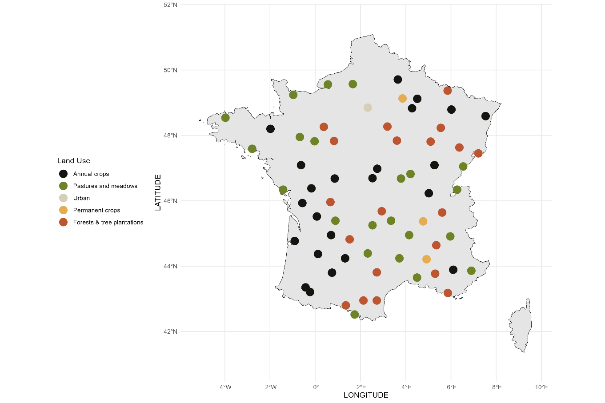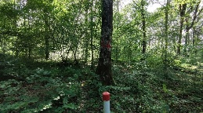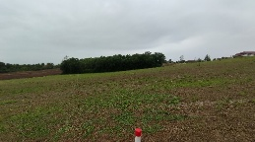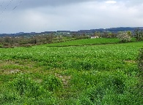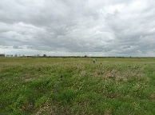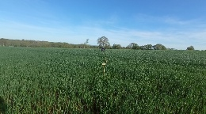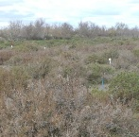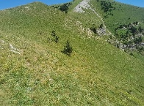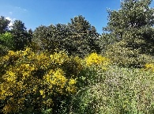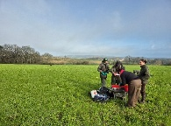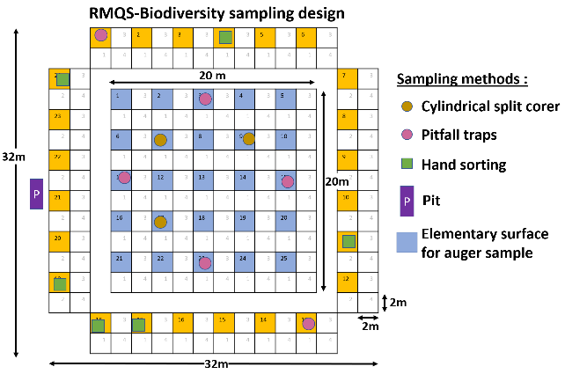

A

B

C

Figure 1. Spatial distribution of soil biodiversity sampling stations across major land use types in mainland France (A), with some photos illustrating the diversity of the stations (B) and description of the sampling surface (C).

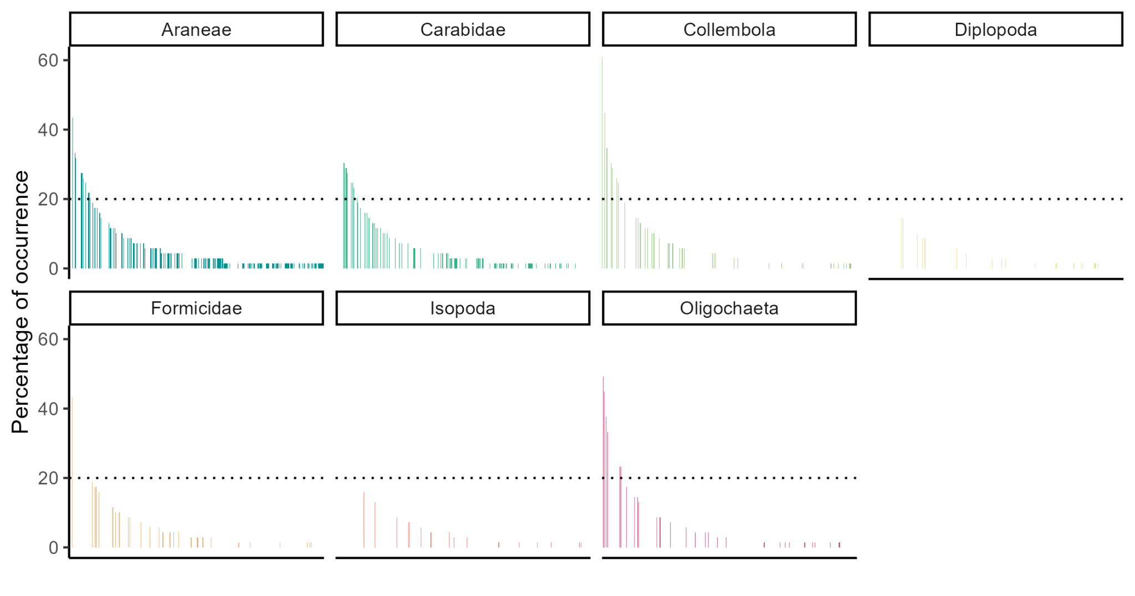

Figure 2. Species occurrence across seven soil fauna groups. Each bar represents the proportion of RMQS-Biodiversity sites where a given species was detected, ranked by decreasing occurrence within its group and over all groups. The dotted line marks the 20% threshold distinguishing common species (≥20% of sites) from rare species (<20%).

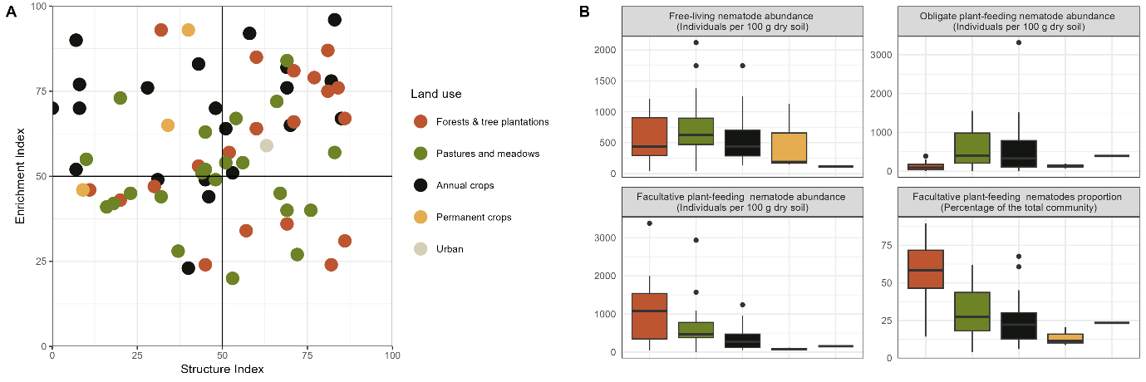

b

b

a

b

b

a

b

a

a

a

a

a

Figure 3 Nematofauna indicators across land uses. A) Relationship between the Structure Index (SI) and the Enrichment Index (EI) across different land uses. The dots are colored according to land uses. The four quadrants represent different nematode community conditions, with SI reflecting food web complexity and EI indicating resource availability. B) Boxplots of nematode abundance across land uses for three major trophic guilds: (i) free-living nematodes (including the bacterial-feeders, fungal feeders, and omni-carnivores), (ii) obligate plant-feeder, (iii) facultative plant-feeder nematodes. The fourth sub-figure displays the proportion of facultative plant-feeder nematodes within the total community. Urban park (1 station) and permanent crops (3 stations) are shown for visual comparison but were not included in the statistical analyses due to their very limited sample size. Colour codes for land use are similar to that in Panel A.

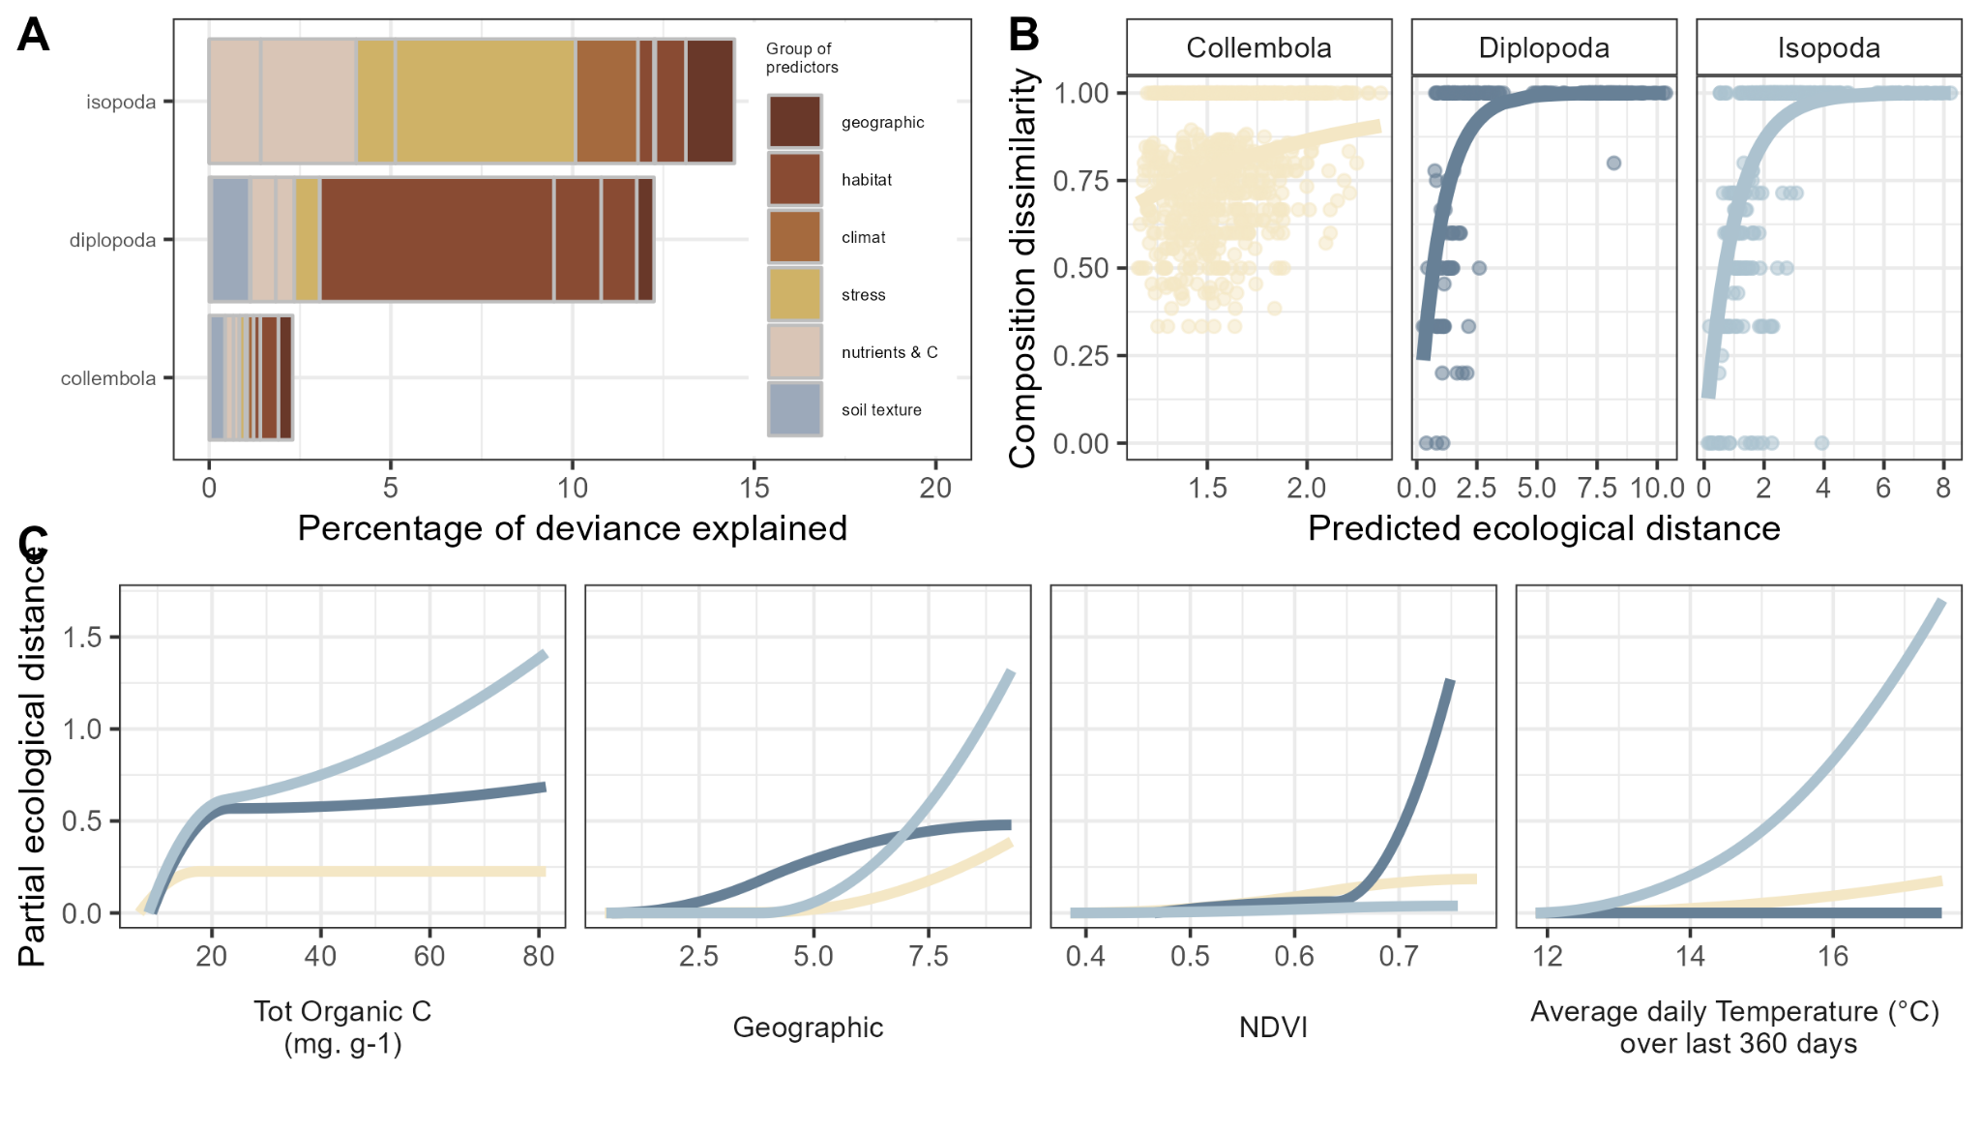

Figure 4. Environmental drivers of detritivore beta diversity. (A) Relative contributions of environmental predictors to community dissimilarity – The percentage of deviance explained by different environmental factors (habitat, climate, soil properties, stress, and geographic distance) for three detritivore groups (Collembola, Isopoda, Diplopoda). (B) Relationship between predicted ecological distance and community dissimilarity – Observed and predicted dissimilarity in community composition as a function of ecological distance for each taxonomic group, illustrating the explanatory power of the GDM models. (C) Response curves of four key environmental predictors – Partial ecological distances associated with total organic carbon, NDVI, geographic distance, and mean temperature over 360 days, showing their nonlinear influence on beta diversity patterns.

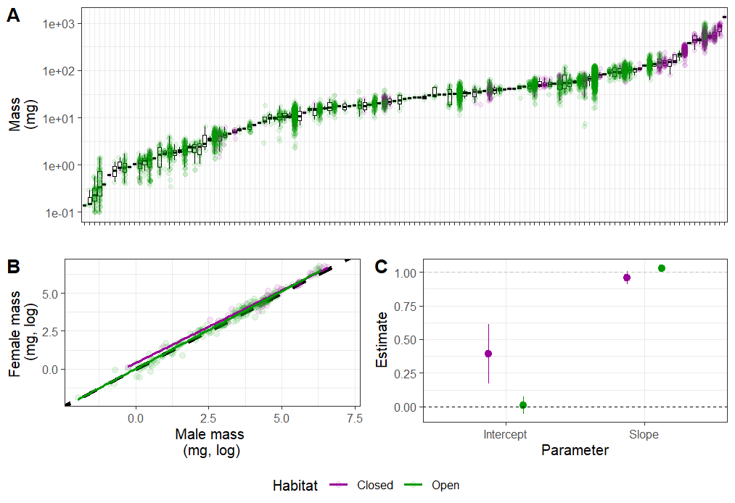

Figure 5. Body mass distribution and sex-based scaling relationships in Carabidae across open and closed habitats. A: Body mass distribution across Carabidae species, with individual points colored according to habitat type (open vs. closed). B: Relationship between male and female body mass (log-transformed) across habitats, with a 1:1 reference line (dashed) and linear regression fits. C: Confidence intervals for slope and intercept estimates from linear regressions in open and closed habitats, showing the variation in sex-based scaling relationships. Statistical differences are indicated when 95% confidence intervals do not cross 0 (for intercepts) or 1 (for slopes), corresponding to a significance threshold of 5%.